**EXECUTIVE SUMMARY**

***Understanding Digital Equity in Washington***

“Access to broadband is the single most important economic development tool in our toolkit right now, and the most necessary to our state.”

–Governor Jay Inslee

**The state of Washington has led digital equity efforts throughout various levels of governance** — from state to local — to bring broadband services and digital skills to all. As a result, Washington state was the only state in the country to receive a perfect score on the State Digital Equity Scorecard when it was launched by the National Skills Coalition, the National Digital Inclusion Alliance, and Microsoft in 2021.[1] Washington state has also been at the forefront of convening an array of partners to solve major issues. During COVID-19, Washington state implemented the Internet Action Connectivity Team (IACT) a statewide collaboration of State Agencies, County, City, Quasi-government organizations, Special Interest Groups (i.e., AARP, Veterans, and housing organization, etc.) and Community Based Organization serving low income and historically underrepresented communities. To continue that legacy, the Washington State Legislature has enacted 2022 legislation that solidifies digital equity into the very framework of Washington’s government by establishing a statewide broadband office, a digital equity forum, and with the passage of a state Digital Equity Act ([HB 1723](https://app.leg.wa.gov/billsummary?BillNumber=1723&Year=2021&Initiative=false)) that includes documenting and promoting digital equity among unserved and underserved communities. Legislation ([HB 1336](https://app.leg.wa.gov/billsummary?BillNumber=1336&Year=2021&Initiative=false) and [SB 5383](https://app.leg.wa.gov/billsummary?BillNumber=5383&Initiative=false&Year=2021)) has also removed certain barriers to getting people connected, such as by allowing public entities to provide retail broadband services directly to end users. The Washington State Office of Equity established digital equity as one of several determinants of equity, which are considered social conditions that “everyone in Washington needs to flourish and achieve their full potential.”[2]

**A diverse ecosystem of digital equity assets and champions has also sprung up from organizations** that understand the advantages of connectivity for all members of society in Washington state. From local libraries providing low-income families with subsidized internet connection plans, to organizations empowering their communities by providing digital literacy workshops. Washington state has seen an enormous, grassroot determination in providing people with the devices, skills, and internet connection they need to access the full benefits of the digital world. The Washington State Broadband Office (WSBO) within the Washington State Department of Commerce continues to lead activities that will encourage, foster, develop, and improve affordable broadband. Activities include funding grants and programs such as the Digital Navigators Program, the Broadband Action Teams, State Broadband Matching Grants, and creating a Drive-in Wi-Fi Hotspot Finder during the peak of the COVID-19 pandemic. The newly formed Digital Equity Unit (DEU) is a team within the WSBO dedicated to addressing digital equity needs. The Digital Equity Unit's mission is to advance digital inclusion for all Washington residents to participate and collaborate online to thrive in today's global society. DEU drives strategies, objectives, and performance through collaborative actions within the WSBO by promoting digital inclusion through affordable access, internet connectivity, adoption, and digital skill building. **Washington state is working together with a wide range of partners to reduce digital inequalities and increase digital inclusion over time.**

“During the pandemic, medicine would come to my grandmother’s door instead of her having to go the pharmacy. She was scared about getting sick. But Wi-Fi didn't work for her, so she wasn't able to let the [person dropping off her medicine] know whether she was home or not. So, it was difficult to have a service so important be in a language that wasn’t her native language, and that needed Wi-Fi to access.”

–Sunnyside listening session participant.

In June 2023, President Biden’s administration announced that Washington state will receive federal funding from the National Telecommunications and Information Administration (NTIA)’s Broadband Equity, Access, and Deployment (BEAD) and State Digital Equity Planning grant programs to expand high speed internet networks and digital equity programs statewide. Washington state consistently ranks among the best-connected state in the country, thanks to the hard work of digital equity champions throughout the decades. However, efforts continue, as there are still over 236,000 locations in Washington that lack broadband service.[3] Disparities exist throughout the state related to access to the internet — either based on the inability to pay, the inability to navigate resources for the adoption of services, the lack of broadband infrastructure in certain areas, the lack of access to digital hardware, or a combination of barriers prohibiting certain individuals from achieving digital access.

**The Washington State Broadband Office and its engagement partners conducted public engagement activities throughout Washington state to hear directly from communities** on the barriers and needs related to accessing, affording, and adopting broadband. Although additional outreach is still needed, to date, the WSBO has hosted more than 30 events and engaged over 3,400 Washington residents between the summer of 2022 and 2023. While this number is not statistically representative of Washington state’s entire population, the WSBO’s outreach was intentional about hearing from underrepresented and under-resourced communities from a multitude of different regions. Public engagement activities were held in person across Washington at libraries, food banks, festivals, bus routes, school buildings, health centers, and community centers, and virtually, to allow for various avenues for engagement. The WSBO also worked with community-based organizations, broadband action teams (BATs), and other agencies to help with outreach. Local and tribal governments were encouraged to create Community Action Plans (CAPs) that detail specific assets, barriers, and potential solutions for their counties. These CAPs were integrated into this Digital Equity Plan to reflect unique local and tribal community needs and strategies. Additionally, as per the NTIA’s requirements and per Washington State’s House Bill 1723, public engagement was also tailored to outreach towards historically unserved and underserved communities, or “covered populations.”[4]

**The WSBO centered the stories told by covered populations** to develop this Plan as they faced numerous compounding barriers to accessing the internet. Based on the findings from the WSBO’s public engagement, this Digital Equity Plan categorizes Washington-specific barriers as either one that a covered population uniquely struggles with or is most prevalent, or a systemic barrier that is beyond the control of any individual. As such, barriers to accessing the internet, devices, and digital skills training, were due to either systemic issues such as a lack of permanent housing, or limited access to transportation, or due to a defining part of their lived experience, such as having limited English proficiency or a disability. Unaffordable services were also a barrier across all covered populations, with many stating that one’s zip code should not limit one’s opportunities for affordable service.

**It is also important to note that populations are not monolithic, and everyone has unique barriers and challenges that can impact their experience** with accessing, affording, or adopting broadband services and digital skills. Consequently, the analysis in this document of Washington-specific barriers is sensitive to the intersectional needs of Washingtonians. To continue expanding and strengthening the WSBO’s understanding of communities and individuals across Washington, public engagement will be ongoing and integrated as a method to measure the success of statewide initiatives to bring internet to all. Continuous steps for engagement will build upon the lessons learned from the WSBO’s initial public engagement period for this Digital Equity Plan and identify where there are opportunities to improve. The WSBO will work to ensure that outreach methods will be culturally appropriate and tailored to the communities they intend to engage. By being sensitive to competing priorities and providing more sessions at different times of the day, by plugging into established community gathering events, and by using trusted avenues of communication, the WSBO intends to continue incorporating the diverse voices of Washington through ongoing public engagement and is open to building more partnerships and suggestions on ways to improve. The state is committed to addressing these barriers by designing actionable, tangible, and sustainable strategies that will be detailed in the following sections of this Digital Equity Plan.

“Access to the internet is essential to participating in modern day society including, but not limited to, attending school and work, accessing health care, paying for basic services, connecting with family and friends, civic participation, and economic survival.”

-House Bill 1723 (Digital Equity Act)

***Charting a course to reach our digital equity goals***

While there are notable barriers to digital equity, there are already many highly engaged community leaders and partner organizations who have been investing in digital inclusion activities and advancing digital equity policies to overcome barriers to access, affordability, and adoption of internet service and information technology. Through extensive conversations in 2022, the state’s Digital Equity Forum developed a vision for digital equity that is adopted in this document as well as by the newly created Digital Equity Unit in the Washington State Department of Commerce:

*Everyone in Washington has affordable broadband internet technology as well as the tools and skills needed to participate in our digital society before 2028.*

Strategies that help define how the work will be completed and measurable objectives that can be used to measure progress will serve as building blocks for achieving goals and the broad vision for digital equity in Washington state, as illustrated in **Figure 1**.

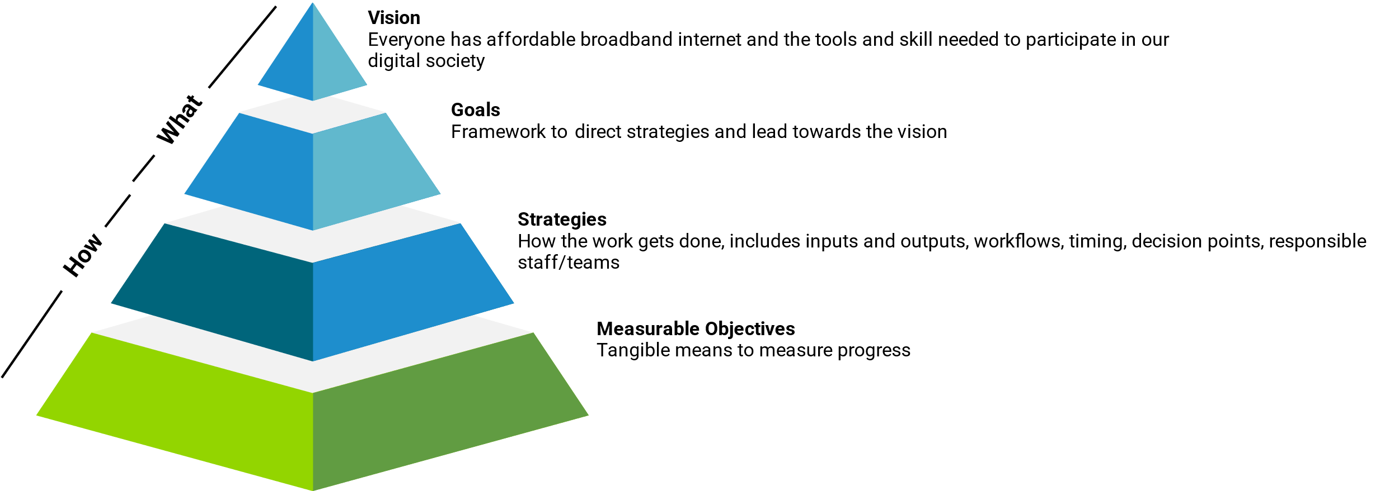***Figure 1: Vision, goals, strategies, and measurable objectives framework***

***Goals***

Three primary goals will serve as the guideposts for the strategies and reflect themes captured during the public engagement to:

1. **Eliminate barriers** to access and affordability.
2. **Empower residents** with the information and digital skills they need to thrive.
3. **Ensure sustainability** of digital equity programs.

|  |  |  |
| --- | --- | --- |
| Eliminate Barriers | Empower Residents | Ensure Sustainability |
| Provide Washington residents with infrastructure, devices, and tools, to maintain reliable, affordable, high-speed broadband service to bridge the digital divide. | Provide Washington residents the information, support, and skills to obtain and cultivate digital knowledge and skills to improve access to reap the benefits of digital inclusion | Establish and build partnerships needed to deliver and sustain broadband service and support programs for learning and engaging in civil society. |

***Strategies***

There are five strategies that will be employed providing measurable outcomes in the delivery of Washington state’s ambitious goals:

1. Increase broadband availability and affordability,
2. Increase device availability and affordability,
3. Online accessibility and inclusivity,
4. Digital literacy, and
5. Online privacy and security.

Strategies for the state of Washington have been developed based on their ability to align with large-scale statewide efforts already in motion to improve outcomes for economic and workforce development, education, health, civic and social engagement, and the delivery of essential services.

Each strategic category will have associated activities to help accomplish the strategy with metrics for progress that are detailed in **Section 2.2.4** Strategy and Objectives and **Section 5.1** Strategy and Key Activities. **Chapter 5** will also dive into the way’s Washington state will measure strategies’ success, mitigate their risks, and ensure their sustainability in the long term. A summary is provided below with strategies mapped to the goal that they support.

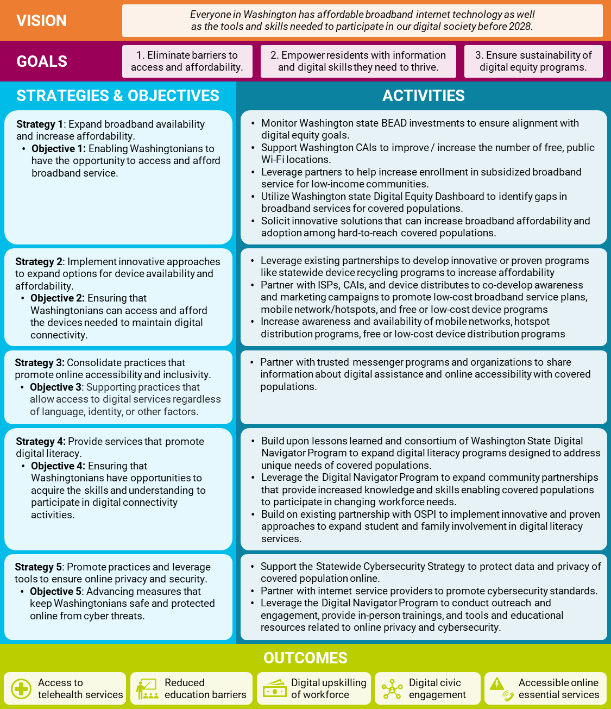***Table 1: Summary of Strategies, Objectives, Activities, and Goals***

***Measuring success***

As strategies are implemented, it will be important to measure progress from the current baseline to desired outcomes on a year-to-year basis over the course of five years. The WSBO will use data already available through various data sources including American Community Survey (ACS) data, Affordable Connectivity Program (ACP) data, and state data sources to establish a baseline and broken out by covered population where possible. These measurable objectives will eventually be incorporated into a digital equity dashboard that the state is currently developing, although not all measures may be included in the first version of the dashboard. Baseline numbers and further explanation of these objectives will be provided in **Chapter 2** of this Plan. Key performance indicators (KPIs) associated with measurable objectives include:

1. The number of Washington residents enrolled in ACP
2. The number of households with various types of digital devices
3. Number of partners participating in training related to online accessibility practices (no baseline currently available)
4. The number of covered populations enrolled in a digital literacy program
5. Tracking the number of existing language access policies per state agencies (no baseline currently available)

***What happens next***

The WSBO wants to emphasize that working towards the vision of digital equity is not something that can or should be done unilaterally. The WSBO intends to continue cultivating partnerships with organizations that are invested in digital equity work and to act as both a connector and a resource whenever possible. The WSBO will work in tandem with partners that include community anchor institutions, Digital Equity Forum, digital navigators, and local and tribal governments to accomplish the strategies and goals laid out in this Plan. The WSBO will continue to engage with and provide progress updates to communities through the outreach and engagement plan described in **Chapter 4**. To accomplish this and do so with the level of trust that will be required, the WSBO intends to engage and compensate community leaders[5] when possible, in facilitating ongoing conversations and holistic, considerate, inclusive input gathering.

Implementation of several strategies identified in **Chapter 5** is already underway and will be coordinated with Broadband, Equity, Access, and Deployment (BEAD) program-related activities. WSBO’s fiscal year 2023 Digital Navigator Program contracted with 32 partners which resulted in 103,532 devices distributed, 152,682 individuals assisted, and 112,773 households provided with a suite of digital navigation services. For example, approximately $14.7M has been made available for the second cohort of digital navigator service providers to be announced in the coming weeks. While there is a great deal of work that remains, progress is already being made. **This work will benefit from the input of many voices across Washington state. The WSBO encourages the public to submit their feedback by visiting the** [**Internet for All in Washington**](https://www.commerce.wa.gov/building-infrastructure/washington-statewide-broadband-act/internet-for-all-wa/) **website.**

1. State Digital Equity Scorecard (2022). Accessed at: <https://state-scorecard.digitalinclusion.org/scorecard/by_state/WA>.
2. Office of Equity Washington State (2023), State of Equity in U.S. and WA State. Accessed at: <https://equity.wa.gov/us-plus/state/state-equity-us-and-wa-state>.
3. Underserved location analysis from FCC v2 fabric data for Washington state.
4. Covered populations are defined in the Digital Equity Act Planning Grant Notice of Funding Opportunity (NOFO) as: 1) individuals who live in covered households (income no more than 150% of the federal poverty level); 2) Aging individuals; 3) Incarcerated individuals; 4) Veterans; 5) Individuals with disabilities; 6) Individuals with a language barrier; 7) Individuals who are members of a racial or ethnic minority group; and 8) Individuals who primarily reside in a rural area.
5. The WSBO will follow [community compensation guidelines](https://equity.wa.gov/people/community-compensation-guidelines) outlined by the Office of Equity.